- Explain R Nuts and bolts in detail. 6 marks
R is the most comprehensive statistical analysis package available. It incorporates all of the standard statistical tests, models, and analyses, as well as providing a comprehensive language for managing and manipulating data.

- R is a programming language and environment developed for statistical analysis by practising statisticians and researchers. It reflects well on a very competent community of computational statisticians.
- The graphical capabilities of Rare outstanding, providing a fully programmable graphics language that surpasses most other statistical and graphical packages.
- R is free and open-source software, allowing anyone to use and, importantly, to modify it. R is licensed under the GNU General Public License, with copyright held by The R Foundation for Statistical Computing.
- R has no license restrictions (other than ensuring our freedom to use it at our own discretion), and so we can run it anywhere and at any time.
- Anyone can provide new packages, and the wealth of quality packages available for R is a testament to this approach to software development and sharing.
- R has over 4800 packages available from multiple repositories specializing in topics like econometrics, data mining, spatial analysis, and bio-informatics.
- R is cross-platform. R runs on many operating systems and different hardware. It is popularly used on GNU/Linux, Macintosh, and Microsoft Windows, running on both 32 and 64 bit processors.
- R plays well with many other tools, importing data, for example, from CSV files, SAS, and SPSS, or directly from Microsoft Excel, Microsoft Access, Oracle, MySQL, and SQLite.
- It can also produce graphics output in PDF, JPG, PNG, and SVG formats, and table output for LATEX and HTML.
- R has active user groups .

- What are different data types supported in R. Explain them in brief 7 marks

In R, data types represent the structure of the data stored and manipulated within the environment. Below is a detailed explanation of each type with simple examples:
- Numeric
Description: Numeric data types store numbers, which can be either integers or real (floating-point) numbers.
Example:
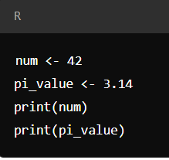
Usage: Used for mathematical calculations, statistical analysis, and operations involving numbers.
- Integer
Description: Integers are whole numbers without decimal points. In R, integers are explicitly defined using the as.integer() function.
Example:
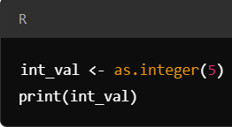
Usage: Used when precise integer values are required.

- Character(String)
Description: Character data type is used to store text strings, which can include letters, words, or sentences.
Example:
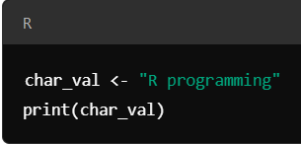
Usage: Useful for storing and processing text data, labels, and categorical values.

- Logical
Description: Logical data types store Boolean values, which are either TRUE or FALSE. These are often the result of logical conditions or comparisons.
Example:
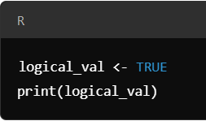
Usage: Used in control flow, logical operations, or data filtering based on conditions.

- Complex
Description: Complex numbers in R have a real and an imaginary part. They are written in the form a + bi, where i is the imaginary unit.
Example:
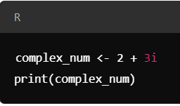
Usage: Useful for advanced mathematical operations that require imaginary numbers.

- Explain different ways of reading data in R (5 marks)

Here are explanations of the principal functions used for reading data into R, categorized based on their purpose:
- read.table() and read.csv()
These functions are commonly used for reading tabular data. read.table() can handle text files with any delimiter, while read.csv() is specifically designed for comma-separated files.
  - read.table(file, header=TRUE, sep="\t") – Reads a tabular text file.
  - read.csv(file, header=TRUE) – Reads a CSV file.
- readLines()
This function reads lines from a text file, making it useful for non-tabular or unstructured data.
  - readLines(file) – Reads each line as a character string and returns a vector of lines.
- source()
The source() function is used to read and execute R code from an external file. It is typically used for running scripts.
  - source(file) – Loads and executes the R code in the file.
- dget()
This function reads R objects that were saved in a text format using dput(). It is used for restoring individual R objects.
  - dget(file) – Reads and reconstructs an R object from a text file.
- load()
The load() function is used to read data saved in an R workspace or .RData file. It restores all saved objects.
  - load(file) – Loads the workspace and makes the objects available in the R environment.
- unserialize()
This function reads and reconstructs a single R object saved in binary form. It's used in more advanced applications.
  - unserialize(file) – Recreates an R object from its binary representation.
Each of these functions serves a specific purpose, from reading tabular data to restoring complex R objects, allowing for a wide range of data inputs into R.

- Name and Explain the following 8 marks
- Basic Operations
- Basic statistics pertaining to R

Basic Operations in R
R is a programming language widely used for statistical computing and data analysis. Basic operations in R include:
- Arithmetic operations
These include addition (+), Subtraction (-), Multiplication (*), Division (/) and exponentiation
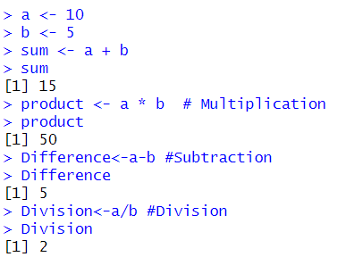
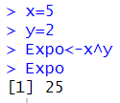
- Relational Operations
These are used for comparison and include greater than( >) or less than (<) and equal to(==) or not equal to (!=)
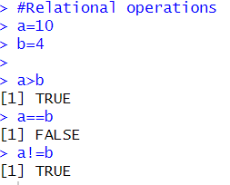

- Logical operations
Logical operations include AND(&) OR(|) and NOT (!)

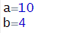
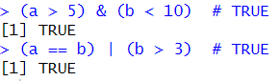
- Assignment operations
R uses assignment operator to assign values to the variable
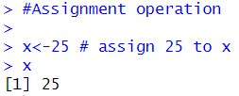

- Indexing and slicing
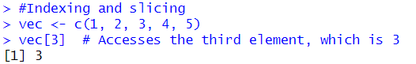

Basic statistics pertaining to R
R provides built-in functions to perform common statistical operations on data.
  - Mean:
The mean is the average value of a data set. You can calculate the mean using the mean() function.
Example:
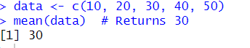
  - Median:
The median is the middle value of a data set. Use the median() function to find it.
Example:
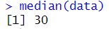
  - Mode:
R doesn’t have a built-in function for mode, but it can be calculated manually using custom code.
  - Variance:
Variance measures the spread of data. It is calculated using the var() function. Example:
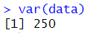
  - Standard Deviation:
The standard deviation is the square root of the variance and can be calculated using sd().
Example:
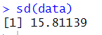
  - Summary Statistics:
R provides the summary () function, which gives an overview of the basic statistics for data, including minimum, first quartile, median, mean, third quartile, and maximum.
Example:

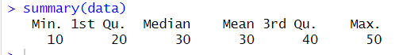

  - Correlation and Covariance:
You can calculate the correlation and covariance between two variables using cor() and cov().
Example:

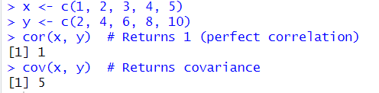

- What are factors in R-language? How are they created? How are they modified? Explain with R code. 6 marks

Factors in R are data structures used to represent categorical data. They store both the values and the corresponding levels (categories). Factors are particularly useful for statistical modelling where categorical variables are treated as distinct levels, rather than numerical values.
Factors are commonly used to represent variables such as gender, country, education level, etc., where the values belong to specific, predefined categories.

Key Characteristics of Factors:
Factors are stored as integers, with each unique level being assigned an integer.
They have a levels attribute, which contains all the unique values or categories.
They can be ordered or unordered. Ordered factors are useful when there is a natural ranking of categories (e.g., "Low", "Medium", "High").
Creating Factors in R
You can create factors using the factor() function. Here's an example:
Example 1: Creating a Simple Factor
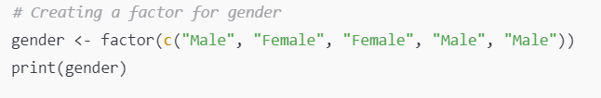
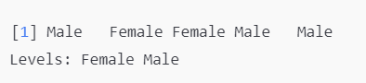
Specifying Levels Manually
You can also manually specify the levels of a factor.
Modifying Factors in R
Once a factor is created, you can modify its levels or values in different ways.
Example : Renaming Factor Levels
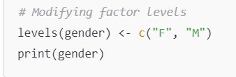
In this example, the levels of gender are renamed from "Female" and "Male" to "F" and "M", respectively.
Adding or Dropping Levels
You can also add or drop levels when modifying factors.
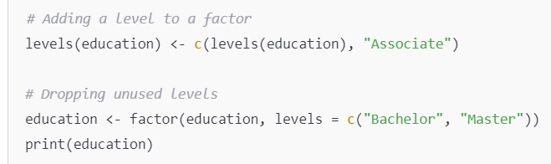
In this example, we first add a new level "Associate" to the education factor, then drop unused levels to only retain "Bachelor" and "Master".

- Describe most commonly used data plots for statistical analysis in R language. 6 marks

In R, data visualization plays a critical role in understanding the patterns, trends, and relationships within the data. Several types of plots are frequently used for statistical analysis, and R provides powerful functions for creating these plots. Below are the most commonly used data plots, along with their purposes and examples:

- Scatter Plot
Scatter plots are used to visualize the relationship between two continuous variables. They help identify potential correlations or patterns such as linear or non-linear relationships.

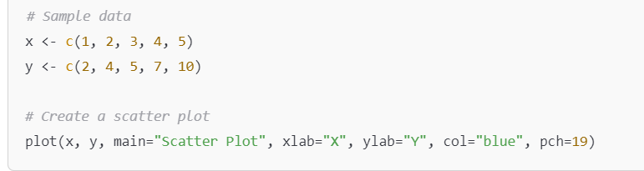
- Interpretation: Each point represents an observation's values for two variables. You can assess the strength and direction of the relationship (positive, negative, or no correlation).

- Box Plot
Box plots (or box-and-whisker plots) are used to visualize the distribution of a variable and to identify outliers. They summarize data in terms of quartiles and highlight the median, interquartile range, and outliers.
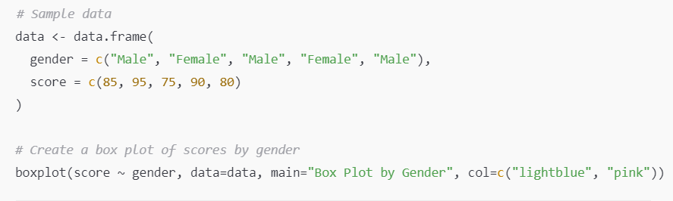
Interpretation: The box represents the interquartile range (middle 50% of data), the line inside the box is the median, and whiskers extend to the minimum and maximum values within 1.5 times the IQR. Outliers appear as individual points.

- Histogram
Histograms are used to show the distribution of a continuous variable. They display the frequency of data points that fall within certain ranges (or bins).

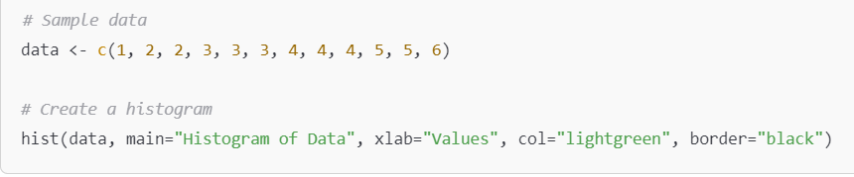
Interpretation: The height of each bar represents the number of observations within each bin. The shape of the histogram reveals the distribution of the data (e.g., normal, skewed).

- Bar Plot
Bar plots are used to represent categorical data. Each bar’s height represents the frequency or count of a category.
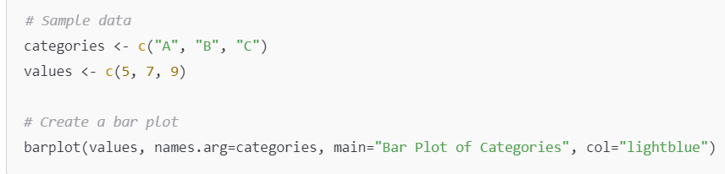
- Interpretation: Bar plots show the frequencies of different categories. They are useful for comparing the counts of different groups.

- Line Plot
Line plots are used to visualize trends over time or other ordered data. They are commonly used in time series analysis.
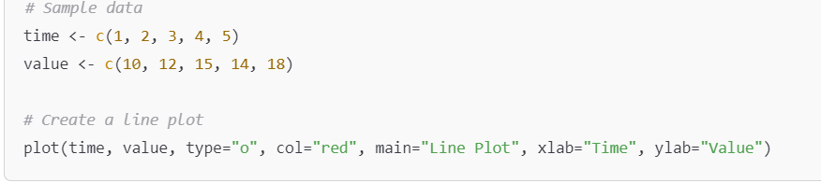
- Interpretation: The line connects data points, making it easy to identify trends, peaks, and dips over time.

- Density Plot
A density plot is a smoothed version of a histogram and is used to visualize the distribution of a continuous variable. It estimates the probability density function of the variable.

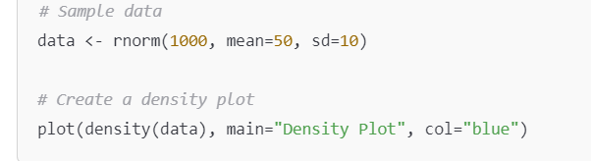
Interpretation: The shape of the density plot helps you understand the underlying distribution of the data, including any skewness or multimodality.

- With reference to the data frames in R language
  - Create a simple data frame from 3 vectors. Order the entire data frame by first column
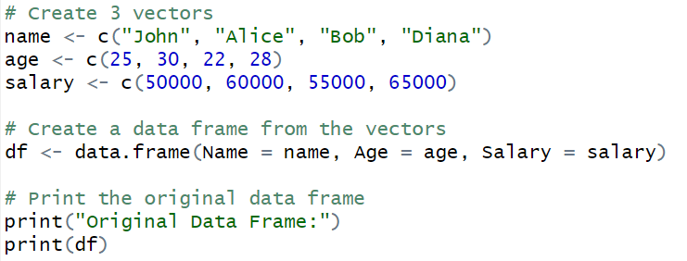

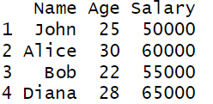

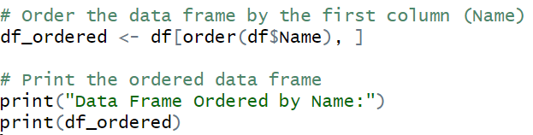

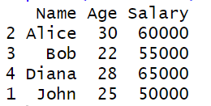
  - Create a data frame from a matrix of your choice, change the row names so every row says id_i (where i is the row number) and change the column names to variable_i (where i is the column number). i.e., for column 1 it will say variable_1, and for row 2 will say id_2 and so on.

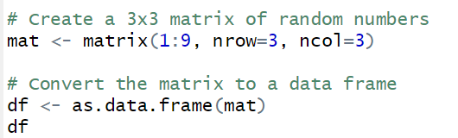

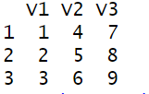

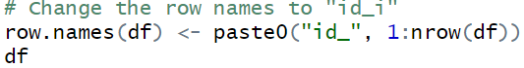
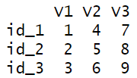
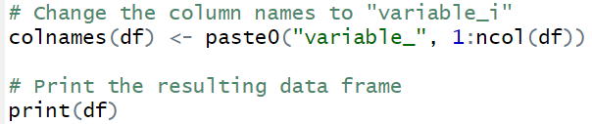
Matrix Creation: A 3x3 matrix is created using the matrix() function.
Convert to Data Frame: The matrix is converted to a data frame using as.data.frame().
Change Row Names: The row.names() function is used to assign new row names in the format id_i, where i is the row number.
Change Column Names: The colnames() function is used to assign new column names in the format variable_i, where i is the column number.
paste0(): This function is used to concatenate strings. It joins "id_" or "variable_" with the row or column numbers.

- Summarize the operations that can be performed on a data frame in R language.
8 marks
A data frame in R is a widely used data structure for storing datasets in a tabular form, where columns represent variables, and rows represent observations. Data frames are highly versatile and offer various operations for data manipulation, analysis, and transformation. Below are the key operations that can be performed on a data frame in R:

1. Creating a Data Frame
You can create a data frame using the data.frame() function by combining vectors of equal lengths
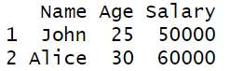
2. Accessing Elements of a Data Frame
You can access rows, columns, or individual elements using indexing or column names.
- Accessing columns: By column name or index.
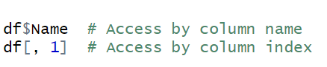
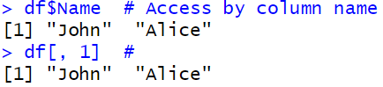
3. Accessing specific elements:
3. Adding Columns or Rows
You can add new columns or rows to an existing data frame.
Adding a new column:
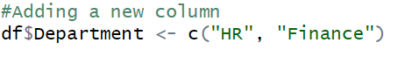
Adding a new row (using rbind()):
4. Modifying Columns or Rows
You can modify existing elements in a data frame by direct assignment.
Modify a column:
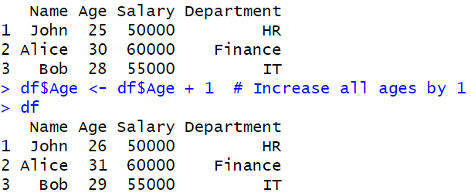
Modify specific row
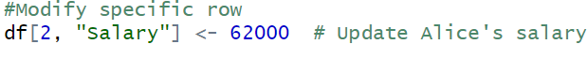
- Filtering Data (Subsetting)
You can filter or subset a data frame based on conditions using logical indexing or the subset() function.
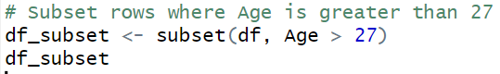

- Sorting a Data Frame
You can sort a data frame by a specific column using the order() function.
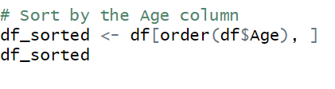
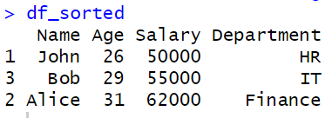

- Summary and Statistical Operations
R provides functions to summarize and compute statistics on data frames.
Summary of the data frame:
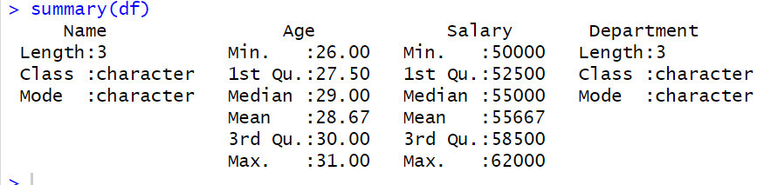

Mean of a numeric column:
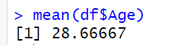
- Merging Data Frames
You can merge two data frames using the merge() function, which works like a SQL join.
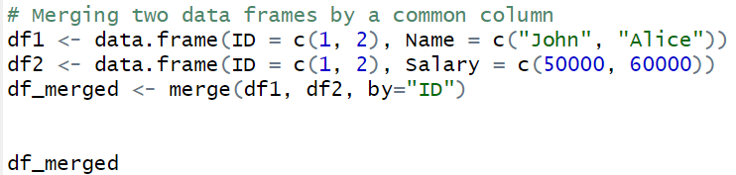

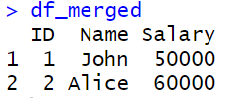

- Point out the functions which are used for the conversion of covariance to correlation in R. Explain the function with syntax and sample data.
In R, the conversion of a covariance matrix to a correlation matrix can be done using the cov2cor() function. This function takes a covariance matrix as input and returns the corresponding correlation matrix.
cov2cor() Function
cov2cor(V)
V: A square covariance matrix.
Explanation:
The cov2cor() function standardizes the covariance matrix into a correlation matrix by dividing each covariance by the product of the standard deviations of the variables. A correlation matrix shows the strength and direction of the linear relationships between variables, while a covariance matrix reflects the variance and covariances in raw units.
2. Example with Sample Data
Let's demonstrate with a sample dataset of two variables: x and y.
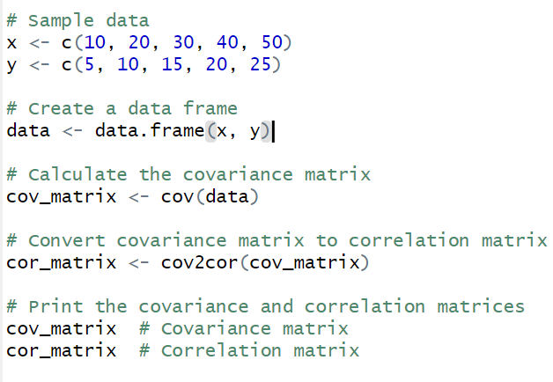
Explanation:
- cov(): This function computes the covariance matrix for the given data. In this case, cov(data) computes the covariance between x and y.
- cov2cor(): This function converts the covariance matrix into a correlation matrix, where the diagonal elements will be 1, and the off-diagonal elements will represent the correlation coefficients between variables.

